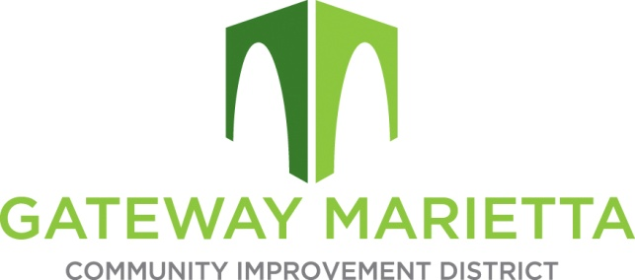

GMCID Board Meeting

Tuesday, January 21, 2025

11:30 AM

1850 Parkway Place Suite 520

Marietta, GA 30067

https://us02web.zoom.us/j/88607072456?pwd=X3QQ6tLgXVHoiabtlFMT6dzqGsxrPS.1

1. Call to Order
2. Approve Minutes of December 16, 2024, Board Meeting and Annual Planning Session
3. Financial Report
4. City Update
5. Projects Update
   1. SMP Quadrants
   2. Delk Road Quadrants
   3. Blanche Underpass
   4. Master Plan
6. Other Business
   1. GMCID Extension of Life
7. Adjourn