\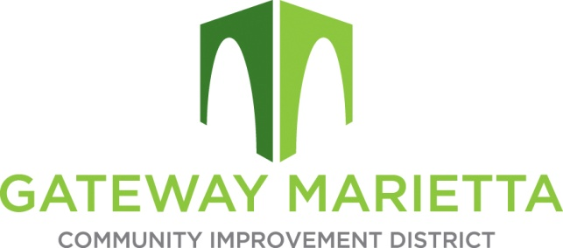

GMCID November 2023 Board Meeting

And 2024 Annual Board Planning

1850 Parkway Place

Suite 520

Marietta, Georgia 30067

November 14, 2023

11:00 AM – 1:00 PM

1. Call to Order
2. Approve Minutes of September 19, 2023 Board Meeting
3. Financial Report
4. City Report
5. Project Updates
   1. Atkins – Blanche Underpass
   2. Winter Design – I-75 Quadrants
   3. Tax Digest Audit
   4. Expansion
   5. Flock Safety
6. Annual Planning
7. 2023 Year in Review
8. 2024 Budget
9. 2024 Project Planning
10. Board Updates
11. Other Business
12. Adjourn