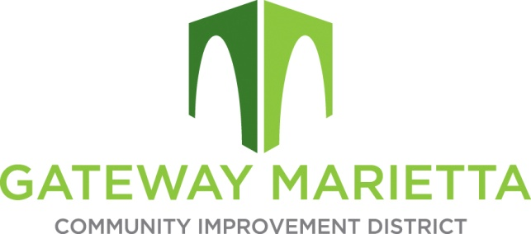
\

GMCID 2022 Board Planning
1850 Parkway Place
Suite 520
Marietta, Georgia 30067
November 15, 2022
11:00 am – 1:00 pm

- Call to Order

- Approve Minutes of September 20 and October 18, 2022 Board Meeting

- Financial Report

- 2022 Year in Review

- 2023 Budget

- 2023 Project Planning

- Board Updates

- Other Business

- Adjourn

