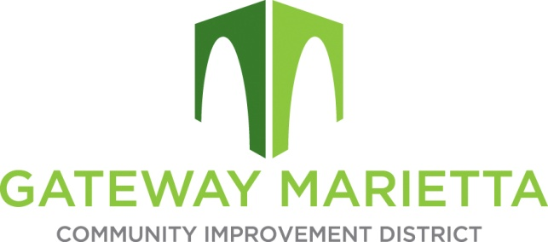

GMCID Board Meeting

Tuesday, May21, 2024

11:30 AM

1850 Parkway Place

Suite 520

Marietta, GA 30067

Zoom Link: https://us02web.zoom.us/j/87962622433?pwd=TFZ1UVdMa2JMaG9ueko1SVVtNEh6dz09

1. Call to Order
2. Approve Minutes of March 19, 2024 Board Meeting
3. Financial Report
4. Discussion and Board Vote on 2024 Millage Rate
5. City Update
6. Projects Update
7. Other Business
8. Adjourn