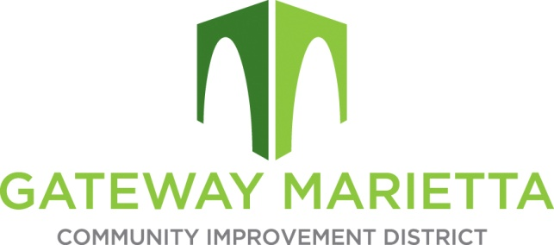

GMCID Board Meeting

Tuesday, September 17, 2024

11:30 AM

1850 Parkway Place

Suite 520

Marietta, GA 30067

1. Call to Order
2. Approve Minutes of July 16 and August 12, 2024 Board Meetings
3. Financial Report
4. City Update
5. Marietta City Police Update
6. \*\*Break for Caucus of Electors at 11:45 a.m.\*\*
7. Election of Officers -- Treasurer
8. Projects Update
   1. Master Plan Consultant Selection
9. Other Business
10. Adjourn