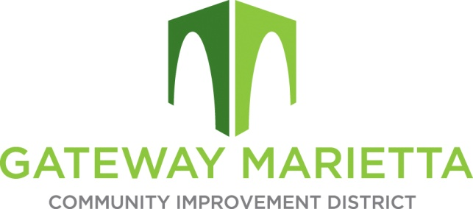

GMCID Board Meeting
Tuesday, January 17, 2023
11:30 AM
1850 Parkway Place Suite 520
Marietta, GA 30067

- Call to Order
- Approve Minutes of November 15, 2022, Board Meeting and Annual Planning Session
- Financial Report
- City Update
- Projects Update
- Other Business
- Adjourn

