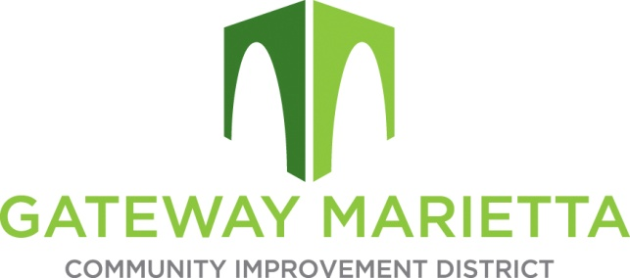

GMCID Board Meeting
Tuesday, February 28, 2023
11:30 AM
1850 Parkway Place Suite 520
Marietta, GA 30067

- Call to Order
- Approve Minutes of January 17, 2023, Board Meeting
- Financial Report
- City Update
- Marietta Police Department Update
- Projects Update
- Other Business
- Recess for Executive Session, if necessary
- Adjourn

