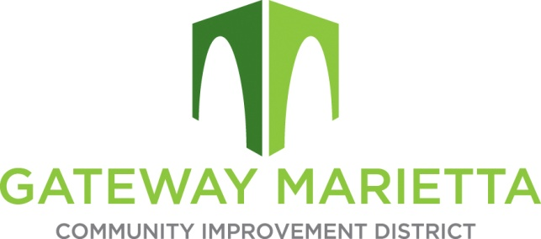

GMCID Board Meeting
Tuesday, July 21, 2026
11:30 AM
1850 Parkway Place, Suite 520
Marietta, GA 30067

Virtual Link:
https://us02web.zoom.us/j/84549660897?pwd=KtF8br2QGHTMUiYF6lXALbmGiB1lgc.1

- Call to Order
- Approve Minutes of May 12, 2026, Board Meeting
- Financial Report
- City Update
- Projects Update
  - Enhancements Update
  - ARC Application Status
- Other Business
  - Discussion of Board Leadership Roles
- Adjourn

