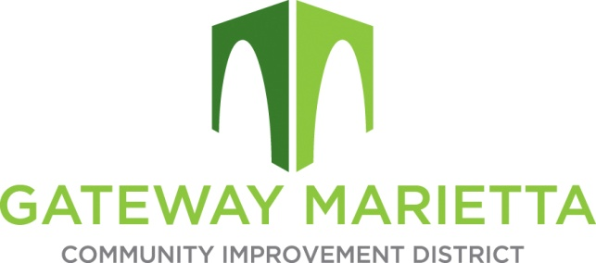
\

GMCID Board Meeting
1850 Parkway Place
Suite 520
September 20, 2022
11:30 AM

- Call to Order
- Approve Minutes of July 19, 2022 Board Meeting
- Financial Report
- **Break for Caucus of Electors at 11:45 a.m.**
- City Update
- Project Updates
- Other Business
- Adjourn

